Concierto Lead Intelligence
End User Guide
AUDIENCE  All users | VERSION  V 1.0 | LAST UPDATED  October 2026

What Is This App?
Concierto Lead Intelligence is a tool built for the Trianz sales team that helps you quickly decide how much attention a prospect deserves. You enter a few details about the person or company you are speaking with, and the app gives you an instant qualification — telling you whether this lead is hot, worth pursuing, needs more nurturing, or should be set aside.
It also uses AI to write a short analysis, recommend the right Trianz services, and draft an outreach email — so you leave every qualification with more than just a number.
How It Works — Four Simple Steps

1  Fill In  Enter lead details  and signal scores | 2  Get a Score  The app calculates  a tier instantly | 3  Read the Insights  AI explains the result  and what to do next | 4  Save & Act  Save to History and  follow next actions

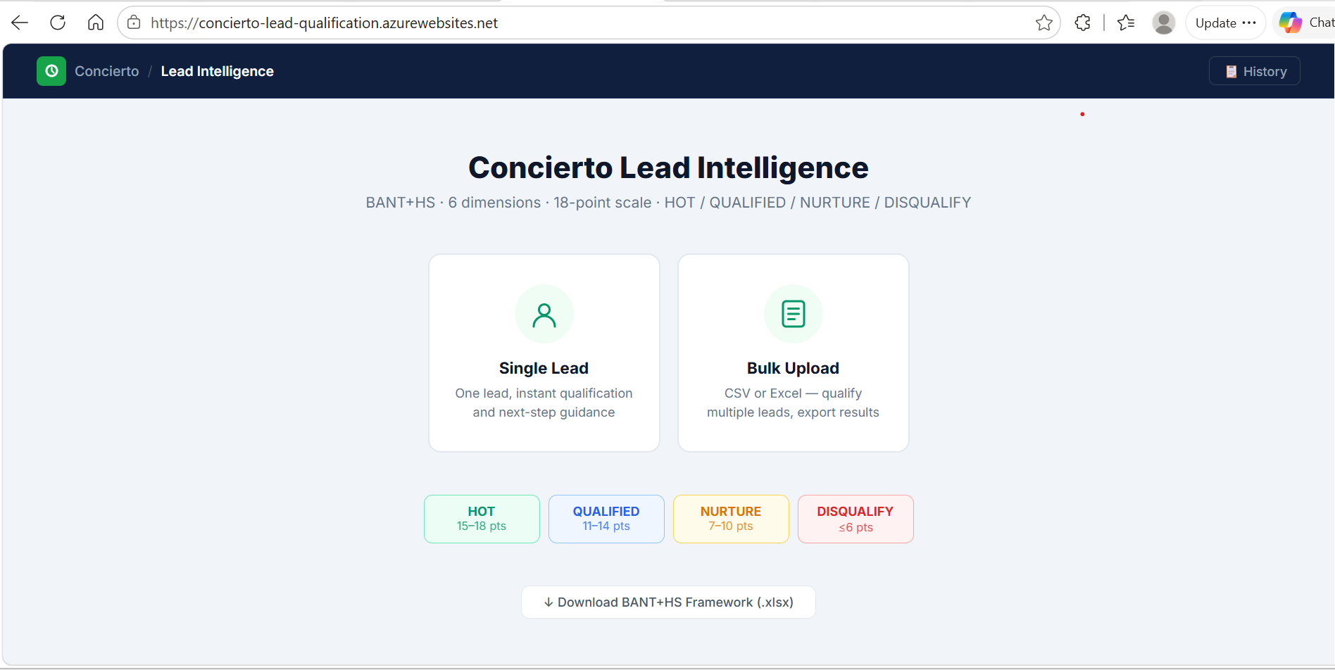
The home screen — choose Single Lead to qualify one prospect, or Bulk Upload to process a full list at once.

First time? After signing in with your Trianz Microsoft account, the app may ask for your email address. Type it in — this is how the app saves your work under your name.

Understanding Your Result — The 4 Tiers
Every lead you qualify comes back with one of four results, called tiers. The tier is based on a score out of 18, calculated from the six signal inputs you provide.
🔥 HOT | Score: 15 – 18 | High priority. Move fast — involve senior team, push to proposal.
✅ QUALIFIED | Score: 11 – 14 | Worth pursuing. Start a proper sales process and schedule discovery.
🌱 NURTURE | Score: 7 – 10 | Too early to push. Keep warm and check back in 30 – 60 days.
✕ DISQUALIFY | Score: ≤ 6 | Not a good fit right now. Park it — do not spend sales hours here.

The 6 Signals — What Are They?
These are the six areas the app checks when scoring a lead. For each one, you choose a level — from "nothing confirmed" to "fully confirmed." Think of them as six simple questions:
Signal | Plain-English Question to Ask Yourself
B Budget | Do they have money approved and ready to spend?
A Authority | Are you speaking with someone who can make the final decision?
N Need | Have they clearly explained what they need help with?
S Scope | Is there a specific project or initiative already underway?
T Timeline | Do they have a deadline or a real sense of urgency?
H Hyperscaler | Are they working with the cloud platforms Trianz specialises in?

Score each signal from 0 (nothing confirmed) to 3 (fully confirmed). Maximum total: 18 points.

Not sure what level to pick? When in doubt, choose the lower option. It's better to score conservatively and revisit when you have more information than to overestimate a lead.

Qualifying a Single Lead — Step by Step
Use this when you have one specific prospect to evaluate. It takes about two minutes.
1 | Open Single Lead. From the home screen, click the Single Lead button.

2 | Fill in the basic details. Company name, contact name, title, industry, revenue range, and which cloud platforms they use.

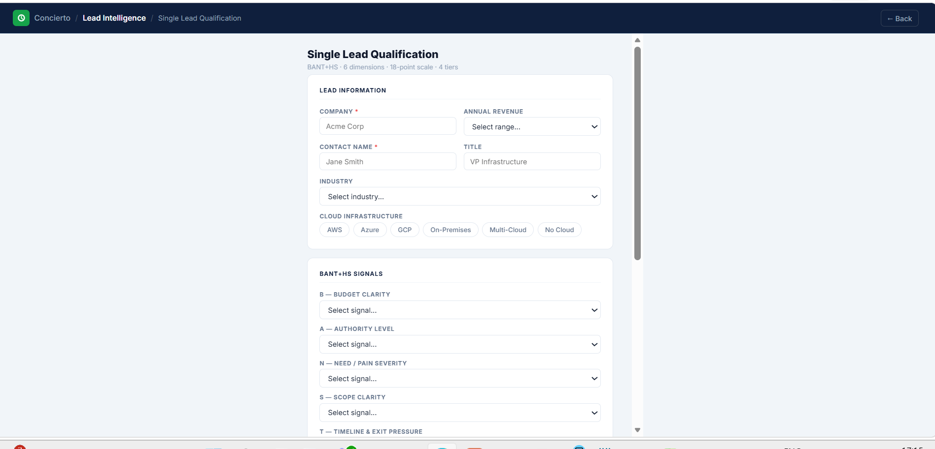
The Single Lead form — fill in company and contact details, select cloud infrastructure, then score each BANT+HS signal.
3 | Score the 6 signals. For each BANT+HS area, pick the option that best matches what you know. 0 = nothing confirmed, 3 = fully confirmed.

4 | Add context notes (optional). Any extra detail from a discovery call or prior research — this helps the AI give better, more specific recommendations.

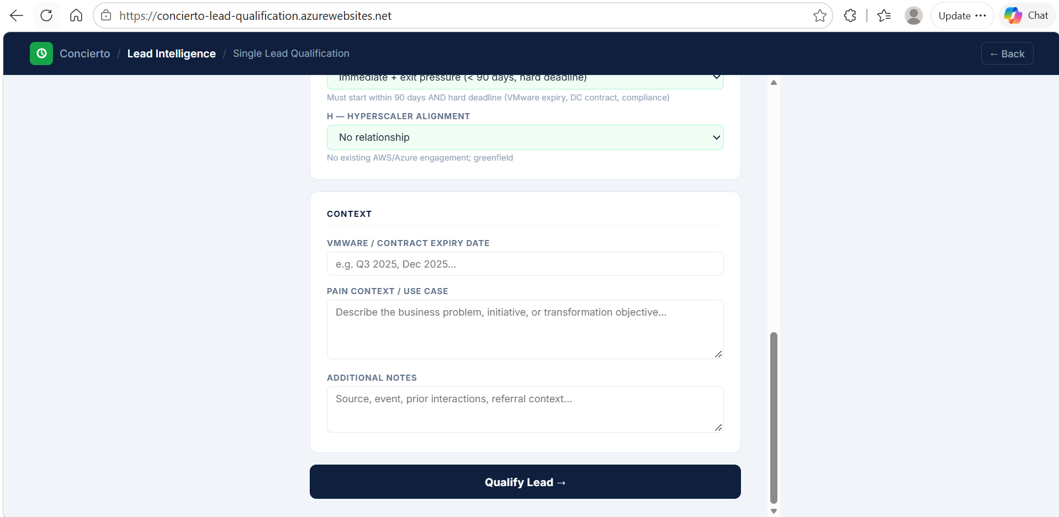
Scroll down to add context notes — including contract expiry dates, pain points, or any relevant background — then click Qualify Lead.
5 | Click Qualify Lead. The app scores the lead instantly. The AI analysis takes 6–10 seconds to generate.

6 | Review your result and save. Read the insights, copy the email draft if useful, then click Save Lead to History.

What You Will See on the Result Screen

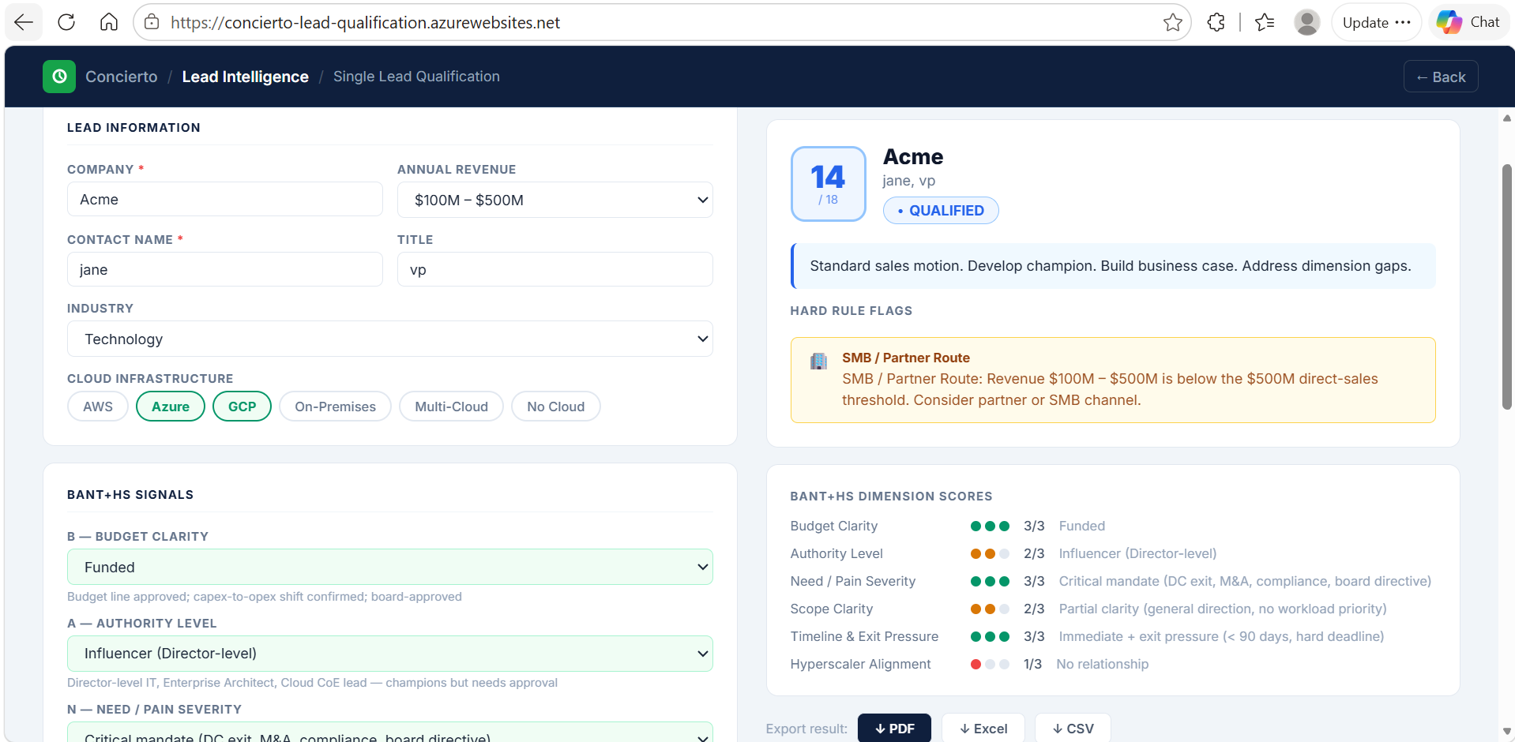
The result screen — score out of 18, tier badge, per-dimension breakdown, and flags shown instantly alongside your form input.

→ Tier badge — the big coloured label (HOT / QUALIFIED / NURTURE / DISQUALIFY)
→ Score — a number out of 18, with a coloured dot breakdown per signal
→ Analyst notes — plain-English explanation of the tier and key signals
→ Recommended services — which Trianz offerings best match this prospect
→ Next actions — specific things to do, tagged High / Medium / Low urgency
→ Discovery questions — questions to ask in your next call to strengthen weak signals
→ Outreach email draft — a ready-to-personalise email to copy into Outlook
→ Flags (if any) — warning banners for things to watch, like "no confirmed budget"

See an authority flag? This means you may be speaking with someone who cannot approve the deal. Use the suggested discovery question to find the right decision-maker and loop them in early.

Working with Many Leads at Once — Bulk Upload
If you have a spreadsheet of leads from a campaign, event, or CRM export, you can qualify all of them in one go — no need to enter each one individually.
1 | Prepare your file. A CSV or Excel (.xlsx) file where each row is one lead. Include columns for Company, Contact, Industry, Revenue, Cloud, and signal scores for B, A, N, S, T, H (each 0 to 3).

2 | Upload the file. Click Bulk Upload on the home screen, then drag your file into the drop zone or click to browse. The app auto-detects columns. Limit: 500 leads per batch.

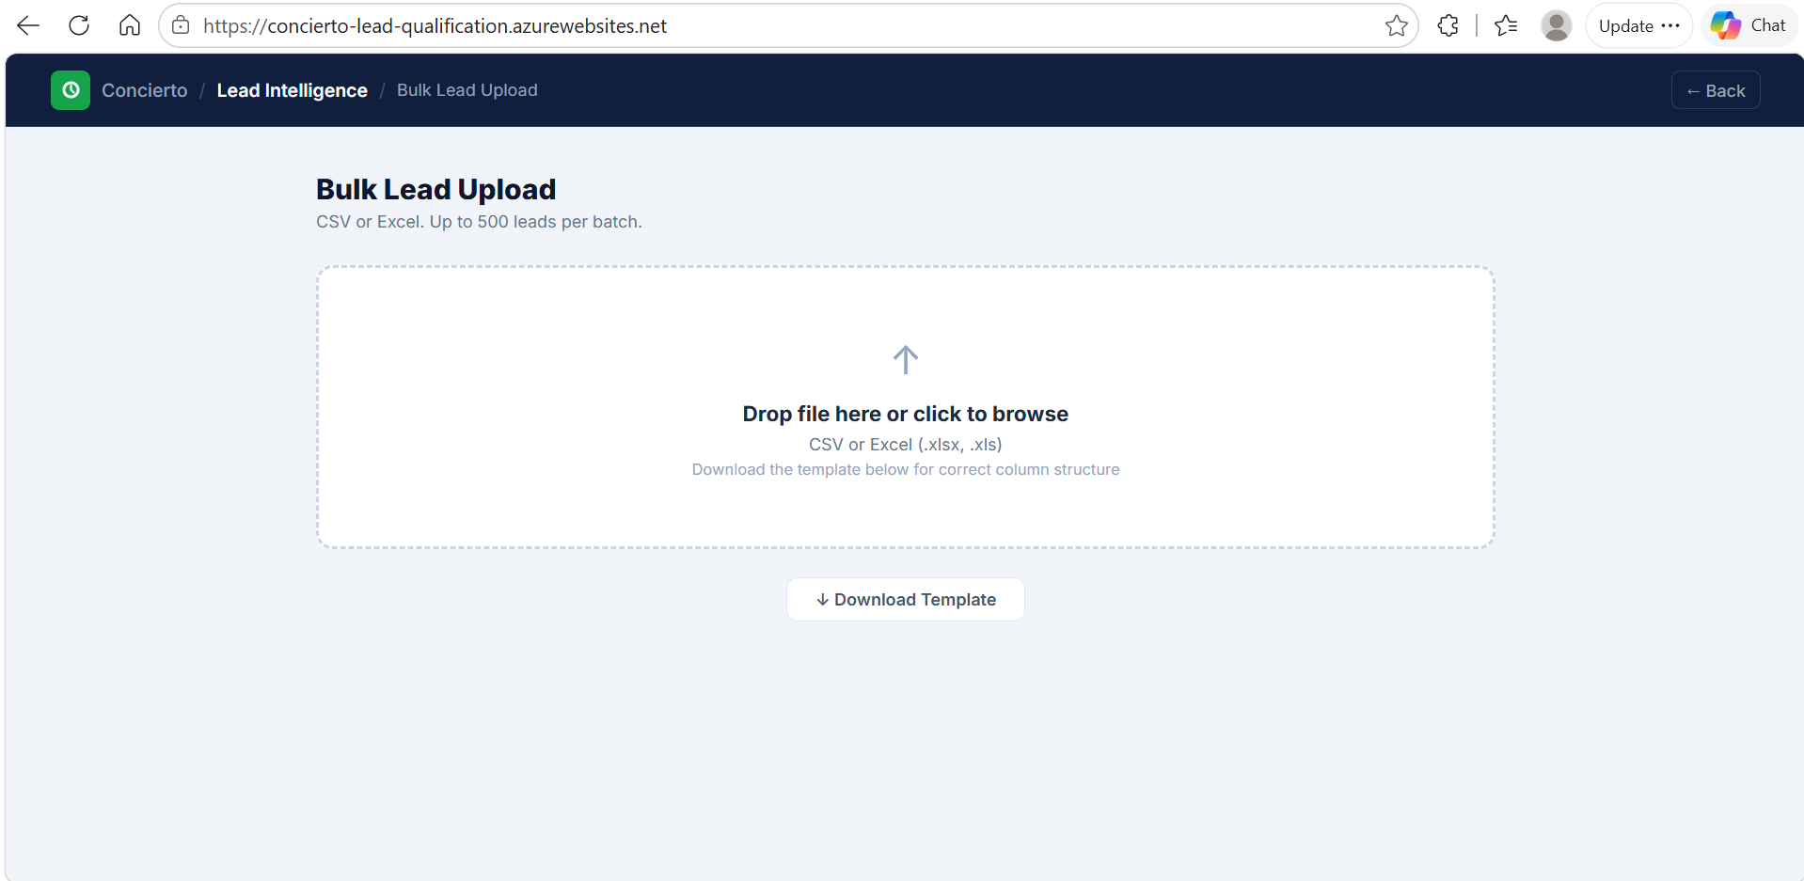
The Bulk Upload screen — drag your CSV or Excel file into the drop area, or click to browse. A template file is available to download if you need the correct column format.
3 | Review results. All leads are scored and shown instantly. Use the tier filter buttons (HOT / QUALIFIED / NURTURE / DISQUALIFY) or the search bar to find specific leads.

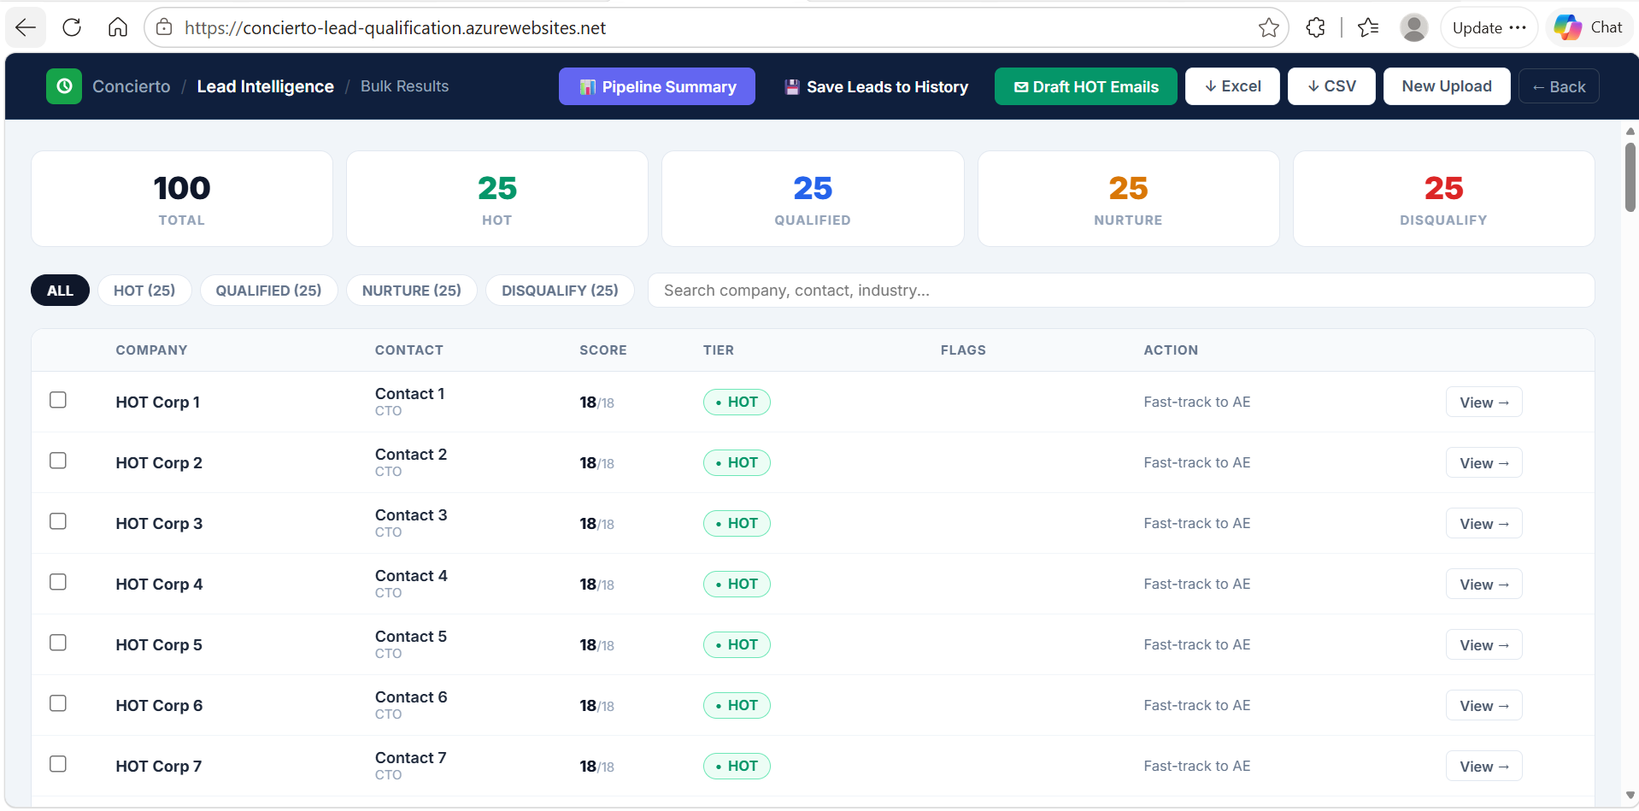
Bulk results dashboard — 100 leads scored instantly. Totals per tier are shown at the top. Use the filter tabs or search bar to focus on the leads that matter most.
4 | Export or take action. Download as Excel, CSV, or PDF. Click Save Leads to History to store the batch. Use Pipeline Summary for an AI executive overview of all results.

Additional Features in Bulk Mode

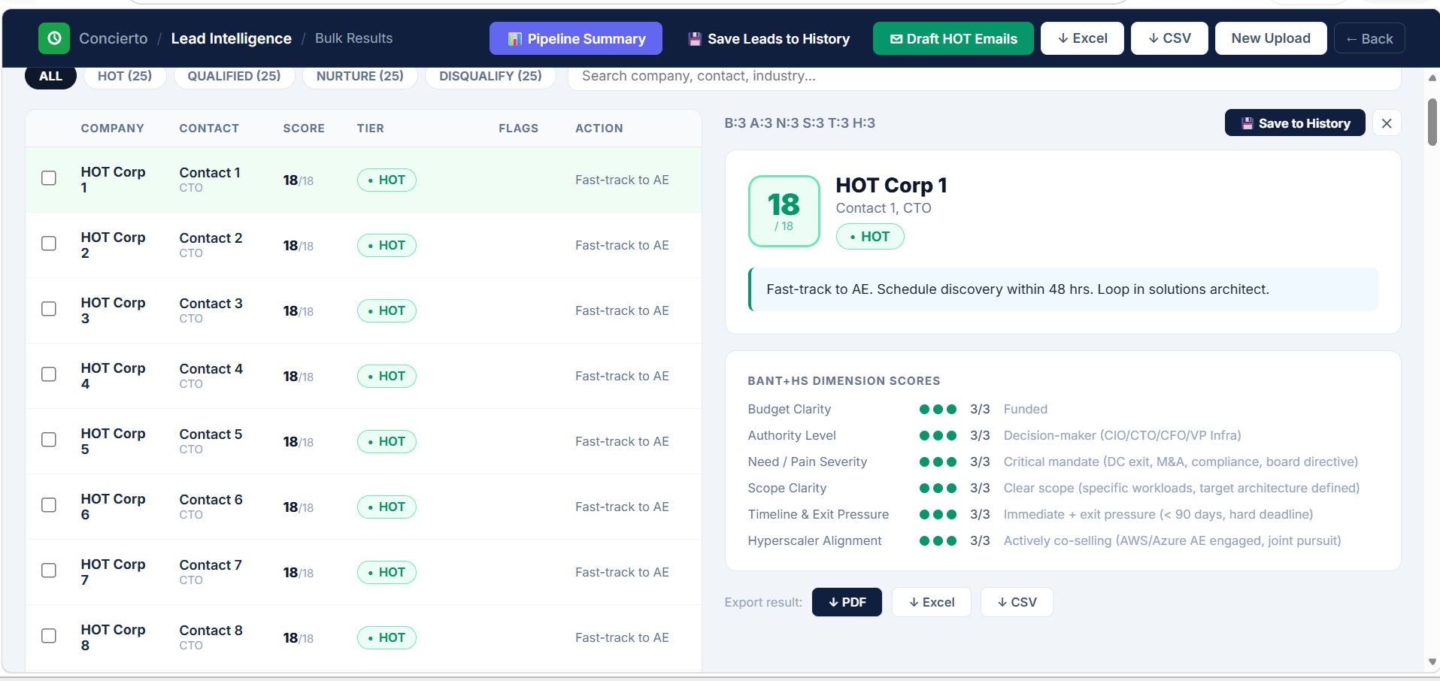
Click any lead row to open its full breakdown in a side panel — view the score, dimension ratings, and recommended action without leaving the results view. Save individual leads from here too.

→ Pipeline Summary — AI-generated executive overview of the full batch, useful for reporting
→ Draft HOT Emails — generates personalised outreach emails for your top HOT leads in one click
→ Individual lead view — click any row to open the full result and save that lead on its own

Your Lead History
Every lead you save — from single or bulk mode — is stored in Lead History. Click the History button in the top right corner from any screen to access it.

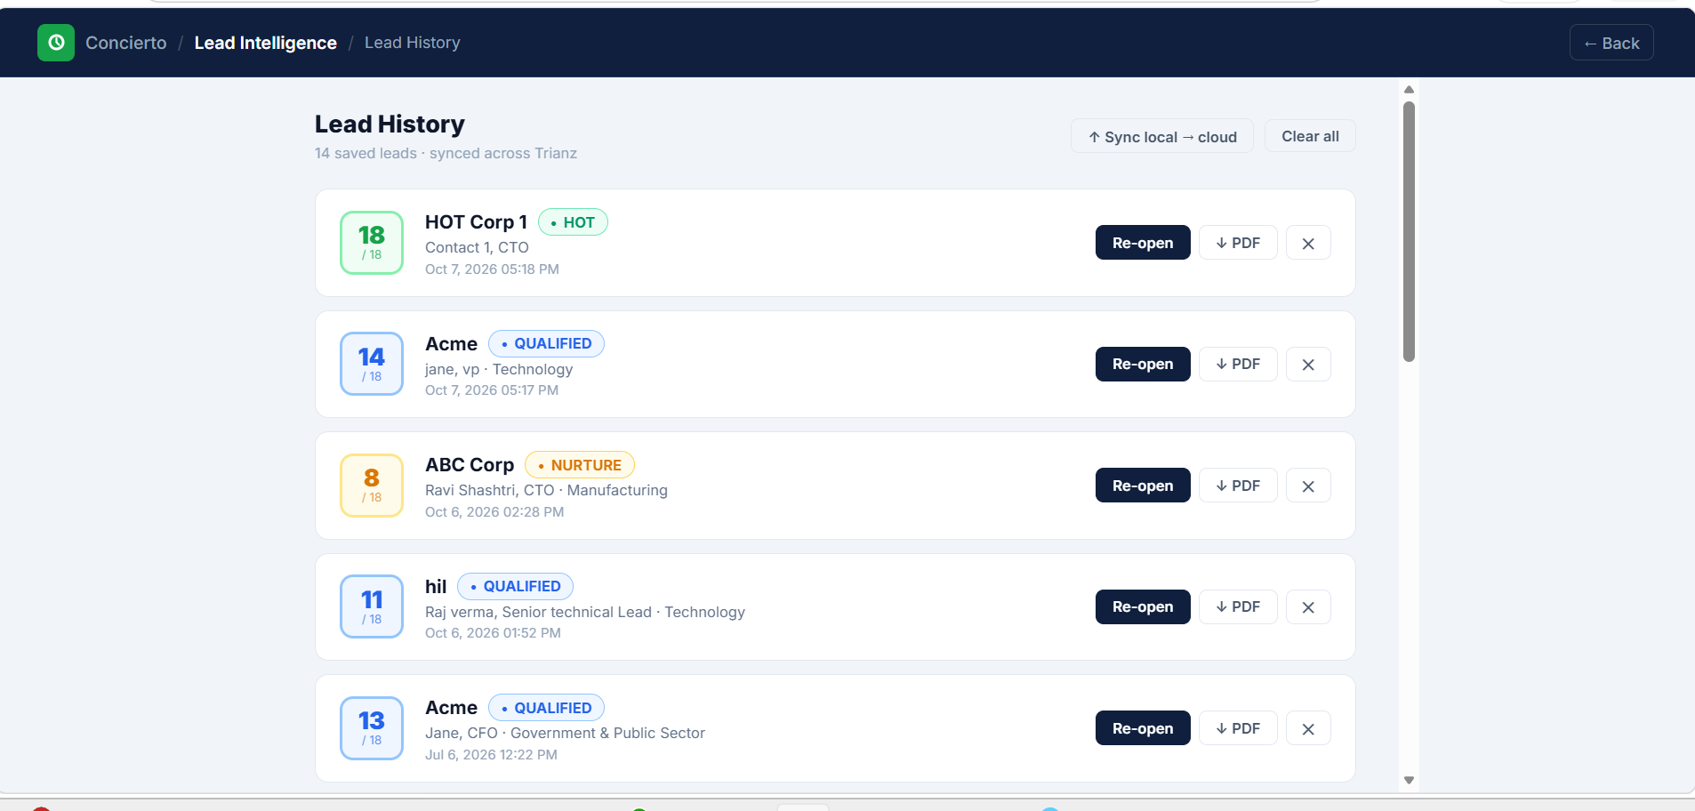
Lead History — all saved leads listed with score, tier badge, contact details, and date saved. Click Re-open to view the full result again, or download a PDF for any individual lead.

→ Re-open a lead — click Re-open on any saved lead to view the full result again
→ Export as PDF — download a formatted PDF for any individual lead directly from History
→ Delete — remove individual leads using the × button on each row
→ Clear All — wipe your entire history (you will be asked to confirm first)
→ Sync to Cloud — if you used the app offline, click this to push everything to the shared database

Is history shared? Lead history is stored in a shared Trianz database. Each lead shows who submitted it, so you always know whose work is whose.

Quick Reference
Use this table to recall what each tier means and what to do next.
Tier | Score | What It Means | What To Do Next
🔥 HOT | 15–18 | Highly qualified, urgent | Involve senior team, prepare proposal immediately
✅ QUALIFIED | 11–14 | Good lead, proceed formally | Schedule discovery call, start sales process
🌱 NURTURE | 7–10 | Potential, not ready yet | Keep warm, revisit in 30–60 days
✕ DISQUALIFY | ≤ 6 | Poor fit at this time | Park it, redirect sales effort elsewhere

Where to Find Key Features

What You Want to Do | Where to Go
Qualify one lead | Home screen → Single Lead
Qualify many leads at once | Home screen → Bulk Upload
View saved leads | History button — top right corner, any screen
Export results | Results screen → Export Excel / CSV / PDF
AI summary of all leads | Bulk results → Pipeline Summary
Generate outreach emails | Single result or Bulk → Generate Emails
Sync offline data to cloud | History → Sync to Cloud

Concierto Lead Intelligence · Internal Trianz Tool · For support or feedback, contact the team that built this application.

